A prisoner snatch on the Eastern Front

18th June 1943:An extended excerpt from a Red Army officer's recollections of the preparation for battle in the Kursk salient
JUN 18

SHARE

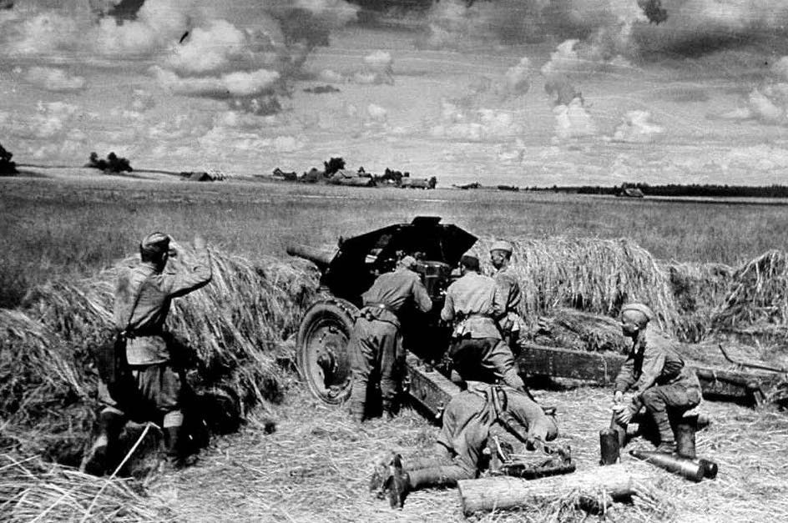
On the plains near Kursk hundreds of thousands of men were preparing themselves for battle. The sheer numbers involved left no doubt about the scale of the anticipated conflict. The element of surprise had long ago been lost, as both sides made their preparations. Yet intelligence was always needed about what enemy units were facing them and what they were doing.
The following extended excerpt comes from the memoirs of Petr Mikhin, Guns Against the Reich: Memoirs of an Artillery Officer on the Eastern Front. In June 1943 he found himself selected to lead a patrol to snatch a prisoner - because he had managed to capture some prisoners a year earlier, while at Rzhev. It was an unusual task for an artillery officer and always a highly dangerous exercise. He well knew that similar patrols had suffered serious casualties, or not returned at all:

When I announced to my observers that we had been ordered to snatch a prisoner, the guys blanched. We all regarded this order as a death sentence, but no one uttered a word against it. Everyone knew that it was impossible to snatch a prisoner and it was also not possible to make it back alive. But each one of us understood: a talking prisoner was vitally important.
We started to look for a place to launch our manhunt. On the right flank of our division at the village of Khotomlia, the Donets made a wide loop and swung deeply into a German-controlled forest. At nearly the same point, a tributary flowed into the Donets from the east, from our side of the river. Between the mouth of the tributary and the bend in the river, a large swamp had been formed, about 2 kilometers wide, which was split in half by a slough. At the top of the loop in the river, the currents had created a wide island.
An idea struck us: What if we tried to make our way across the swamp, the slough and the island, and there, deep in the German rear, swam across the Donets right under the noses of the Germans? Far from the front lines, the Germans were probably less vigilant.
I ordered the sergeant to find a boat and prepare a group of ten men for the mission. Together with Korennoi, who had been with me on that snatch mission back at Rzhev, I decided once the sun set to make our way across to that precious island and from its banks monitor the Germans on the other side of the river.
Once it grew dark, we picked up an infantry lieutenant and several infantrymen for escort and moved out. We crossed our barbed-wire fence and minefield, advanced about another couple hundred meters through no-man’s- land in the direction of the swamp, and reached an outpost: here, in tall grass, a machine-gun nest with a phone line had been concealed.
The infantry lieutenant and his men remained here, while Iasha and I eased our way further into the unknown, towards the swamp, dropping at every sudden flare of an illumination round. We had to determine if the swamp was passable, whether or not Germans were on the island, and assess the river channel. It turned out that the swamp was completely overgrown with thick grass, split only by the shallow water and reeds of the slough. The dense grass, deep mud and clumps of duckweed slowed us down. When a flare burst into light, we ducked under the water.
The water was first knee-deep, then waist-deep and in some places up to our chins. In order not to leave a trail behind us - the Germans would have noticed it immediately the next morning among the undisturbed grass - we zigzagged sharply to the left and right. Although this lengthened our path, it also ensured that the grass and reeds obscured the trace we were leaving behind as we moved.
Finally we stepped onto the firm ground of the island. We camouflaged ourselves on our bank of the river channel, now 2 kilometers from our own lines and in the German rear. We listened closely and peered into the darkness of the opposite bank. There was dead silence. No hum of activity, no sounds, and no flickers of campfires. It had to mean that the opposite bank was unguarded. At dawn we saw the opposite bank: it was steep and forested.
Parallel to the river bank and about 50 meters away from it stretched a barbed wire fence. Through binoculars, I could spot tripwires in the area between the barbed wire and the river, which meant it was mined. The emptiness of the far bank made me both happy and anxious: where were the Germans? We waited.
Just after sunrise, in the bushes among the trees we caught the flash of two white hats. The German cooks, with submachine-guns dangling from their necks and buckets in their hands, made their way through passages in the barbed wire and minefield and noisily ran down to the water. They cautiously and diligently took a look around, and examined our bank with particular thoroughness to make sure there were no Russians there. Once satisfied, they tossed several hand grenades into the water, gathered up the stunned fish, filled their buckets with water and headed back. These were the little dears we’d be pinching tomorrow, Korennoi and I happily thought.
Not a single soul appeared on the far shore for the rest of the day. Only from time to time did some muffled voices carry to us from the depths of the woods beyond the river. As darkness fell, we set off on our journey back. When we got back to our trenches, we found ten men ready with a boat and full gear. We hoisted the boat onto our shoulders and, without wasting a second, we traced our path back to the island.
Again, water, grass, and zigzagging. We barely managed to drag the boat up to the slough, as we no longer had any strength to carry it on our shoulders.
Korennoi got into the boat and started to row it down the slough to the main channel of the river, telling us to meet him with the boat at the spot where we’d been sitting that day to observe the German side of the river. I led the rest of the team to the location on the island — but Iasha and the boat weren’t there! Had the Germans caught him? Terrible anxiety seized my heart. We felt sorry for Iasha, but also knew that the operation was over without the boat. But a moment later, we calmed down when Korennoi’s boat slid into the grass along the bank.
I quickly reviewed the actions that the men should take in different possible situations. I left a support group on our bank, ordering them immediately to dig a trench in the bushes, and then with the capture group I crossed the river to the other bank. Beforehand we had tied a long German steel cable to the stern of the boat, and when we reached the German bank, I attached another long cable to the bow. At my signal, the support group pulled the boat back to the island using the cable attached to the stern, while I played out the cable attached to the bow.
I then placed the end of the cable under the water to conceal it. Once on the other shore, the support group hid the boat in the tall grass. The German bank was sandy and completely barren, so there was no place to hide a boat. We settled into the bushes close to the water, next to the path that the cooks had taken. With the sunrise, we waited for the cooks to appear.
We waited and waited. The morning passed and was closing on lunch-time, but there was no sign of the Germans. Upset, chewed up by mosquitoes, hungry, and in foul spirits, we lost hope. Were they really not going to show at all? In this case with the coming of darkness, we would have to crawl through the German minefield and over the barbed wire, search for a dugout and seal it off - and this would be a very risky proposition, from which we might not return and never even reach a German to capture.
… my mate and I were to kill the German on the left, the powerful Zakharenko and another scout were to capture the German on the right, the fifth man would cover the path down to the river with his submachine-gun, while the sixth man would locate the cable and haul the boat back to our bank.
Our entire plan of operations had been based exclusively on the appearance of the Germans on the river bank and that they would enter the water. Our roles had been distributed accordingly: my mate and I were to kill the German on the left, the powerful Zakharenko and another scout were to capture the German on the right, the fifth man would cover the path down to the river with his submachine-gun, while the sixth man would locate the cable and haul the boat back to our bank.
We had completely given up on the appearance of the German cooks, when suddenly above us we heard the clink of empty jerrycans. What a joy - they were coming! Then worry: how would everything turn out? We had planned to capture them at dawn, when everyone was still asleep, but here we were now in the afternoon and all the Germans were up and about, while our guys on the opposite bank likely weren’t waiting for us, expecting that we had postponed the operation until nightfall.
We looked up: two Germans were standing by the barbed wire. They were young blond men in black uniforms without helmets, with submachine-guns hanging from their necks and jerrycans in their hands. These were no cooks - they were tankers! They seemed struck by the beauty of the verdant meadow across the river, illuminated by the setting sun.
But time was passing! The Germans were lost in admiration, while we were tense with anticipation, and I almost wanted to cry out: ‘What are you standing around for, get down to the river!’ Finally, the Germans ran past us at a trot. They waded into the river, leaned over, and lowered the empty jerrycans into the river, before lifting their heads and examing our bank of the river carefully. Bubbling and splashing, the jerrycans slowly began to fill. I silently lifted and then sharply dropped my right hand - the signal to spring into action.
In two bounds I was at the left-hand German and had already raised my knife to strike him, when the German abruptly stepped away from the bank, tossed aside the canisters, grabbed for his submachine-gun and started to turn to face me. Our rapid approach across the sand had been silent; the German could hardly have heard it, but more likely some instinct or intuition had kicked into gear. Using my momentum, I piled onto his back and grabbed his weapon with my left hand, while my right hand began to stab repeatedly at his chest.
Shifting his submachine-gun around to his front, the German parried my blows, while trying to turn his weapon on me at the same time. Finally I delivered the decisive strike and the German went limp. At that moment the German on the right began to howl as if he’d been sliced, and indeed he had been. I handed my German over to my partner, who to this point had been doing nothing behind my back, and told him to finish the German off and to search his pockets, while I rushed over to Zakharenko to keep him from killing the intended prisoner!
It turned out that Zakharenko, having pounced on the prisoner, had wanted to shove a piece of cloth into his mouth, but couldn’t get it out of his pocket. So he had instead grabbed a handful of sand and stones and had tried to shove that into the German’s mouth.
I rolled up my side cap and stuck it into the Nazi’s mouth, and he fell silent. It turned out that Zakharenko, having pounced on the prisoner, had wanted to shove a piece of cloth into his mouth, but couldn’t get it out of his pocket. So he had instead grabbed a handful of sand and stones and had tried to shove that into the German’s mouth. The German had practically bitten off Zakharenko’s thumb in the process and had violently kicked Zakharenko with his boot. Just a piece of bone was left of Zakharenko’s thumb. Wild with the intense pain, the scout had planted his knife into the German’s side, which is when the German started to howl.
We heard cries of alarm from above us. Firing on the move, Germans were already running through the forest in our direction. Our man responsible for the boat couldn’t find the end of the cable in the water, panicked, and swam across the river to our side, although later he told us that he had gone to get the boat. We made so many mistakes due to our lack of professional training! I ran a little deeper into the water, located the cable and hauled the boat back to our bank. We tossed the wounded German on his back into the boat, I jumped on top of him and the guys on the other bank started to pull us through the water.
Five of the scouts, already in the river, grabbed onto the sides of the boat. The cable was as tight as a string! It seemed about to snap! The five men hanging onto the sides of the boat increased its resistance many times over. I watched the vibrating cable with unimaginable fear, expecting it to break at any second, and already picturing how the current would sweep us under the fire from German bunkers ... but the cable held. As soon as the scouts could stand up in the water, they started pushing the boat towards the bank. Finally, hustling our prisoner along, we ran over to the prepared trench.
I was calming the guys, bandaging the German, but thinking to myself with alarm: now the Germans would grab the boat that we had left, cross the river with some reinforcements, engage us in combat and we would remain on this island forever together with the prisoner.
The Germans opened fire at our bank with every available weapon. We waited out this furious barrage in the trench. Artillery shells and mortar rounds exploded nearby, but we were unharmed, sheltered by the deep trench. After some minutes the Germans slowly shifted their wall of fire into the swamp, assuming we were now crawling through the tall grass of the swamp towards our lines.
The Germans opened fire at our bank with every available weapon. We waited out this furious barrage in the trench. Artillery shells and mortar rounds exploded nearby, but we were unharmed, sheltered by the deep trench. After some minutes the Germans slowly shifted their wall of fire into the swamp, assuming we were now crawling through the tall grass of the swamp towards our lines. We sat a bit longer in the trench, and then moved out at a crawl through the tall grass at a respectful distance behind the walking barrage. Again we zigzagged in our movement and it was a long, hard journey through the swamp until we reached our lines.
We dropped into our trench barely alive; it was already dark. The entire division quickly learned about our success through the phone network and celebrated, knowing how costly the previous attempts to snatch a prisoner had been. Finally, we had one in our trench!
All the top brass, right up to the army headquarters, were also happy. An interpreter, sent to us by the division commander beforehand, was waiting for us in the dugout. He immediately began to interrogate the prisoner; everyone was afraid that the wounded man might die.
The Nazi, in the hope of medical assistance and that his life would be spared, quickly spilled the truth: he was part of the Grossdeutschland Panzer Division, just arrived from France.
By morning we, together with the German, were at division headquarters. Division commander Colonel Fadeev embraced each one of us and promised to decorate us.
[It was, however, not quite the end of the episode.]
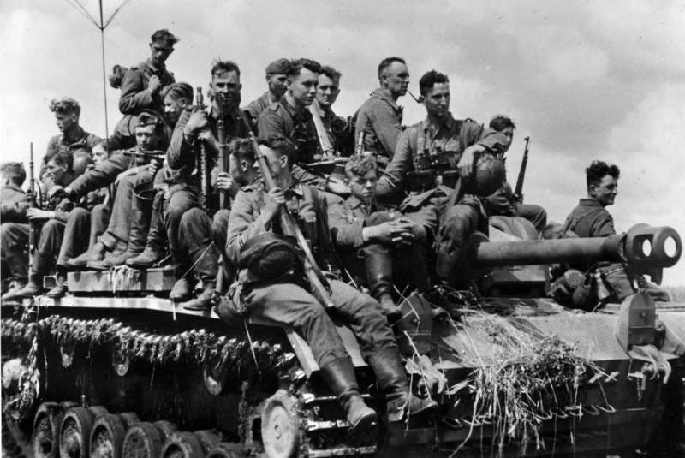
This excerpt from Guns Against the Reich: Memoirs of an Artillery Officer on the Eastern Front appears by kind permission of Pen & Sword Books Ltd. Copyright remains with the author.

